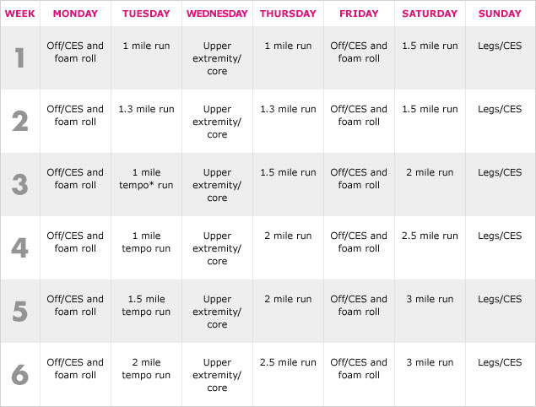
Here are examples of the exercises to do on non-running days.

Upper Extremities
Push- ups, Seated row, Dumbbell reverse fly

Core
Sit Ups, Cable trunk rotations, Plank/side plank

Lower Extremities
Squats with dumbbells, Kettlebell deadlifts Box / Curb step-ups with dumbbells

CES (corrective exercises) - to counteract the repetitive motion of running. Examples are wall angles, single leg balances, and dowel rod hip hinges

Foam roll to work out the tightness and kinks in my muscles.

